Supplementary Material

Supplementary Methods
This supplement provides additional model specifications, descriptive context tables, county-year suppression summaries, and supplemental atlas figures. The extraction source trail, processed query inventory, and analytic code are available in the public repository and archived release: https://github.com/blakepi/epilepsy-status-mortality-suppression-atlas-2019-2024; https://doi.org/10.5281/zenodo.20691623.
Suppressed county cells were preserved as bounded 1–9 death intervals. Explicit zero cells were preserved as zeros. Missing or unreturned cells were not treated as zero. County-year data were used for reconciliation and suppression profiling rather than primary county-year modeling because county-year rows were sparse and suppression-heavy.

Supplementary Tables
Table S1. County-year suppression summaries by year and rurality from Q002.
Table S2. Compact suppression-bounds model results for rurality and SVI terms. The full table is available as a separate CSV file in the public repository and archived release.
Table S3. Interval-likelihood negative binomial model summaries and fit diagnostics.
Table S4. Component ACS model collinearity diagnostics.
Table S5. Place of death by urbanization from Q006.
Table S6. Age-group distribution by urbanization from Q007.
Table S7. Sex distribution by urbanization from Q008.
Table S8. Race and Hispanic-origin descriptive tables from Q009A and Q009B.
Table S9. Underlying-cause county suppression profile from Q014.
Table S10. County merge and unmatched FIPS details, including Connecticut geography caveat.

Supplementary Figures and Legends
Figure S1. Observed exact-county multiple-cause G40/G41 rate map.
Figure S2. Rural/high-SVI priority map under residual allocation.
Figure S3. State-period multiple-cause G40/G41 mortality rate map.
Figure S4. County underlying-cause G40/G41 suppression-status map.
Figure S5. National-year mortality trend.

Supplementary Source/Query Inventory
The public repository includes the staged Q001–Q015 processed aggregate CDC WONDER outputs, checksums, extraction inventory, data dictionary, and workflow documentation. The archived release is available at https://doi.org/10.5281/zenodo.20691623.

Supplementary Table Details

Table S1. County-year suppression summaries by year and rurality from Q002.
year | primary_rurality | death_status | rows | lower | upper | population
2019 | metro_large | exact | 115 | 3008 | 3008 | 1.407e+08
2019 | metro_large | suppressed_1_9 | 231 | 231 | 2079 | 4.123e+07
2019 | metro_large | zero | 95 | 0 | 0 | 3.446e+06
2019 | metro_other | exact | 53 | 815 | 815 | 2.505e+07
2019 | metro_other | suppressed_1_9 | 475 | 475 | 4275 | 6.177e+07
2019 | metro_other | zero | 210 | 0 | 0 | 6.739e+06
2019 | nonmetro_adjacent | exact | 1 | 13 | 13 | 8.212e+04
2019 | nonmetro_adjacent | suppressed_1_9 | 501 | 501 | 4509 | 2.024e+07
2019 | nonmetro_adjacent | zero | 542 | 0 | 0 | 1.058e+07
2019 | nonmetro_nonadjacent | suppressed_1_9 | 281 | 281 | 2529 | 7.867e+06
2019 | nonmetro_nonadjacent | zero | 627 | 0 | 0 | 6.89e+06
2019 |  | exact | 3 | 55 | 55 | 2.69e+06
2019 |  | suppressed_1_9 | 6 | 6 | 54 | 8.897e+05
2019 |  | zero | 2 | 0 | 0 | 1.752e+04
2020 | metro_large | exact | 118 | 3770 | 3770 | 1.434e+08
2020 | metro_large | suppressed_1_9 | 242 | 242 | 2178 | 3.99e+07
2020 | metro_large | zero | 81 | 0 | 0 | 2.887e+06
2020 | metro_other | exact | 82 | 1233 | 1233 | 3.497e+07
2020 | metro_other | suppressed_1_9 | 472 | 472 | 4248 | 5.315e+07
2020 | metro_other | zero | 184 | 0 | 0 | 5.975e+06
2020 | nonmetro_adjacent | exact | 2 | 25 | 25 | 1.467e+05
2020 | nonmetro_adjacent | suppressed_1_9 | 549 | 549 | 4941 | 2.136e+07
2020 | nonmetro_adjacent | zero | 493 | 0 | 0 | 9.395e+06
2020 | nonmetro_nonadjacent | exact | 2 | 23 | 23 | 1.512e+05
2020 | nonmetro_nonadjacent | suppressed_1_9 | 328 | 328 | 2952 | 8.687e+06
2020 | nonmetro_nonadjacent | zero | 578 | 0 | 0 | 5.887e+06
2020 |  | exact | 3 | 53 | 53 | 2.684e+06
2020 |  | suppressed_1_9 | 6 | 6 | 54 | 7.745e+05
2020 |  | zero | 2 | 0 | 0 | 1.306e+05
2021 | metro_large | exact | 132 | 3991 | 3991 | 1.488e+08
A compact preview is shown; the full table is available as a separate CSV file in the public repository and archived release.

Table S2. Compact suppression-bounds model results for rurality and SVI terms.
scenario | model_family | model_type | term | irr | ci_low | ci_high | p_value
observed_exact_positive_only | rurality_only | GLM_negative_binomial_alpha1_robust | primary_rurality_nonmetro_nonadjacent | 0.9053 | 0.7691 | 1.065 | 0.2313
observed_exact_positive_only | rurality_svi_composite | GLM_negative_binomial_alpha1_robust | primary_rurality_nonmetro_nonadjacent | 0.9743 | 0.7986 | 1.189 | 0.7977
observed_exact_positive_only | rurality_svi_composite | GLM_negative_binomial_alpha1_robust | svi_quartile_Q2 | 0.9605 | 0.8176 | 1.128 | 0.6238
observed_exact_positive_only | rurality_svi_composite | GLM_negative_binomial_alpha1_robust | svi_quartile_Q3 | 0.9748 | 0.8601 | 1.105 | 0.689
observed_exact_positive_only | rurality_svi_composite | GLM_negative_binomial_alpha1_robust | svi_quartile_Q4_highest | 0.862 | 0.7504 | 0.9901 | 0.03565
observed_exact_positive_only | acs_component_family | GLM_negative_binomial_alpha1_robust | primary_rurality_nonmetro_nonadjacent | 0.9783 | 0.816 | 1.173 | 0.8127
observed_exact_plus_zero | rurality_only | GLM_negative_binomial_alpha1_robust | primary_rurality_nonmetro_nonadjacent | 0.9119 | 0.7988 | 1.041 | 0.1726
observed_exact_plus_zero | rurality_svi_composite | GLM_negative_binomial_alpha1_robust | primary_rurality_nonmetro_nonadjacent | 0.9081 | 0.7766 | 1.062 | 0.2272
observed_exact_plus_zero | rurality_svi_composite | GLM_negative_binomial_alpha1_robust | svi_quartile_Q2 | 0.9817 | 0.8613 | 1.119 | 0.7826
observed_exact_plus_zero | rurality_svi_composite | GLM_negative_binomial_alpha1_robust | svi_quartile_Q3 | 1.045 | 0.9099 | 1.2 | 0.5344
observed_exact_plus_zero | rurality_svi_composite | GLM_negative_binomial_alpha1_robust | svi_quartile_Q4_highest | 1.024 | 0.885 | 1.184 | 0.7532
observed_exact_plus_zero | acs_component_family | GLM_negative_binomial_alpha1_robust | primary_rurality_nonmetro_nonadjacent | 0.936 | 0.8298 | 1.056 | 0.2814
suppressed_equals_1 | rurality_only | GLM_negative_binomial_alpha1_robust | primary_rurality_nonmetro_nonadjacent | 0.9989 | 0.8971 | 1.112 | 0.9844
suppressed_equals_1 | rurality_svi_composite | GLM_negative_binomial_alpha1_robust | primary_rurality_nonmetro_nonadjacent | 0.9845 | 0.8844 | 1.096 | 0.7759
suppressed_equals_1 | rurality_svi_composite | GLM_negative_binomial_alpha1_robust | svi_quartile_Q2 | 1.032 | 0.9397 | 1.133 | 0.5126
suppressed_equals_1 | rurality_svi_composite | GLM_negative_binomial_alpha1_robust | svi_quartile_Q3 | 1.05 | 0.9555 | 1.153 | 0.3125
suppressed_equals_1 | rurality_svi_composite | GLM_negative_binomial_alpha1_robust | svi_quartile_Q4_highest | 1.114 | 1.014 | 1.225 | 0.02521
suppressed_equals_1 | acs_component_family | GLM_negative_binomial_alpha1_robust | primary_rurality_nonmetro_nonadjacent | 0.9651 | 0.8662 | 1.075 | 0.5199
suppressed_equals_5 | rurality_only | GLM_negative_binomial_alpha1_robust | primary_rurality_nonmetro_nonadjacent | 1.294 | 1.182 | 1.417 | 2.507e-08
suppressed_equals_5 | rurality_svi_composite | GLM_negative_binomial_alpha1_robust | primary_rurality_nonmetro_nonadjacent | 1.291 | 1.178 | 1.415 | 4.784e-08
suppressed_equals_5 | rurality_svi_composite | GLM_negative_binomial_alpha1_robust | svi_quartile_Q2 | 0.9217 | 0.8459 | 1.004 | 0.06223
suppressed_equals_5 | rurality_svi_composite | GLM_negative_binomial_alpha1_robust | svi_quartile_Q3 | 0.9879 | 0.9029 | 1.081 | 0.7901
suppressed_equals_5 | rurality_svi_composite | GLM_negative_binomial_alpha1_robust | svi_quartile_Q4_highest | 0.9954 | 0.9124 | 1.086 | 0.9165
suppressed_equals_5 | acs_component_family | GLM_negative_binomial_alpha1_robust | primary_rurality_nonmetro_nonadjacent | 1.244 | 1.139 | 1.359 | 1.292e-06
suppressed_equals_9 | rurality_only | GLM_negative_binomial_alpha1_robust | primary_rurality_nonmetro_nonadjacent | 1.42 | 1.265 | 1.594 | 2.809e-09
suppressed_equals_9 | rurality_svi_composite | GLM_negative_binomial_alpha1_robust | primary_rurality_nonmetro_nonadjacent | 1.423 | 1.266 | 1.598 | 3.135e-09
suppressed_equals_9 | rurality_svi_composite | GLM_negative_binomial_alpha1_robust | svi_quartile_Q2 | 0.8788 | 0.7893 | 0.9785 | 0.0184
suppressed_equals_9 | rurality_svi_composite | GLM_negative_binomial_alpha1_robust | svi_quartile_Q3 | 0.9641 | 0.86 | 1.081 | 0.5302
suppressed_equals_9 | rurality_svi_composite | GLM_negative_binomial_alpha1_robust | svi_quartile_Q4_highest | 0.9555 | 0.8558 | 1.067 | 0.4177
suppressed_equals_9 | acs_component_family | GLM_negative_binomial_alpha1_robust | primary_rurality_nonmetro_nonadjacent | 1.359 | 1.217 | 1.517 | 4.861e-08
A compact preview is shown; the full table is available as a separate CSV file in the public repository and archived release.

Table S3. Interval-likelihood negative binomial model summaries.
model_family | term | coef | se_approx | irr | ci_low_approx | ci_high_approx | n_rows
interval_nb_rurality_only | primary_rurality_metro_other | 0.06009 | 0.3618 | 1.062 | 0.5226 | 2.158 | 3131
interval_nb_rurality_only | primary_rurality_nonmetro_adjacent | 0.04155 | 0.1896 | 1.042 | 0.7188 | 1.512 | 3131
interval_nb_rurality_only | primary_rurality_nonmetro_nonadjacent | 0.07474 | 0.2838 | 1.078 | 0.6179 | 1.879 | 3131
interval_nb_rurality_svi | primary_rurality_metro_other | 0.05195 | 0.4253 | 1.053 | 0.4576 | 2.424 | 3131
interval_nb_rurality_svi | primary_rurality_nonmetro_adjacent | 0.02709 | 0.396 | 1.027 | 0.4728 | 2.233 | 3131
interval_nb_rurality_svi | primary_rurality_nonmetro_nonadjacent | 0.06538 | 0.266 | 1.068 | 0.6338 | 1.798 | 3131
interval_nb_rurality_svi | svi_quartile_Q2 | 0.02954 | 0.8659 | 1.03 | 0.1887 | 5.622 | 3131
interval_nb_rurality_svi | svi_quartile_Q3 | 0.04234 | 0.457 | 1.043 | 0.426 | 2.555 | 3131
interval_nb_rurality_svi | svi_quartile_Q4_highest | 0.07464 | 0.4347 | 1.077 | 0.4596 | 2.526 | 3131

Table S3b. Interval-likelihood fit diagnostics.
model_family | n_rows | converged | message | interval_log_likelihood | alpha
interval_nb_rurality_only | 3131 | True | CONVERGENCE: RELATIVE REDUCTION OF F <= FACTR*EPSMCH | -5172 | 0.1446
interval_nb_rurality_svi | 3131 | True | CONVERGENCE: RELATIVE REDUCTION OF F <= FACTR*EPSMCH | -5169 | 0.1444

Table S4. Component ACS model collinearity diagnostics.
variable | vif | r_squared | n
acs_pct_poverty | 2.912 | 0.6566 | 3129
acs_median_household_income | 2.916 | 0.657 | 3129
acs_pct_high_school_grad_or_higher | 2.391 | 0.5818 | 3129
acs_pct_uninsured | 1.547 | 0.3535 | 3129
acs_pct_non_hispanic_black | 1.345 | 0.2566 | 3129
acs_pct_hispanic | 1.631 | 0.3867 | 3129
acs_pct_age_65_plus | 1.367 | 0.2687 | 3129

Table S5. Place of death by urbanization from Q006.
table | urbanization | place_of_death | death_count_status | rows | lower | upper
place of death by urbanization | Large Central Metro | Decedent's home | exact | 1 | 4880 | 4880
place of death by urbanization | Large Central Metro | Hospice facility | exact | 1 | 788 | 788
place of death by urbanization | Large Central Metro | Medical Facility - Dead on Arrival | exact | 1 | 18 | 18
place of death by urbanization | Large Central Metro | Medical Facility - Inpatient | exact | 1 | 7321 | 7321
place of death by urbanization | Large Central Metro | Medical Facility - Outpatient or ER | exact | 1 | 1043 | 1043
place of death by urbanization | Large Central Metro | Medical Facility - Status unknown | zero | 1 | 0 | 0
place of death by urbanization | Large Central Metro | Nursing home/long term care | exact | 1 | 1747 | 1747
place of death by urbanization | Large Central Metro | Other | exact | 1 | 821 | 821
place of death by urbanization | Large Central Metro | Place of death unknown | suppressed_1_9 | 1 | 1 | 9
place of death by urbanization | Large Fringe Metro | Decedent's home | exact | 1 | 3252 | 3252
place of death by urbanization | Large Fringe Metro | Hospice facility | exact | 1 | 834 | 834
place of death by urbanization | Large Fringe Metro | Medical Facility - Dead on Arrival | exact | 1 | 38 | 38
place of death by urbanization | Large Fringe Metro | Medical Facility - Inpatient | exact | 1 | 5185 | 5185
place of death by urbanization | Large Fringe Metro | Medical Facility - Outpatient or ER | exact | 1 | 673 | 673
place of death by urbanization | Large Fringe Metro | Medical Facility - Status unknown | zero | 1 | 0 | 0
place of death by urbanization | Large Fringe Metro | Nursing home/long term care | exact | 1 | 1479 | 1479
place of death by urbanization | Large Fringe Metro | Other | exact | 1 | 541 | 541
place of death by urbanization | Large Fringe Metro | Place of death unknown | zero | 1 | 0 | 0
place of death by urbanization | Medium Metro | Decedent's home | exact | 1 | 3830 | 3830
place of death by urbanization | Medium Metro | Hospice facility | exact | 1 | 895 | 895
place of death by urbanization | Medium Metro | Medical Facility - Dead on Arrival | exact | 1 | 19 | 19
place of death by urbanization | Medium Metro | Medical Facility - Inpatient | exact | 1 | 5148 | 5148
place of death by urbanization | Medium Metro | Medical Facility - Outpatient or ER | exact | 1 | 612 | 612
place of death by urbanization | Medium Metro | Medical Facility - Status unknown | zero | 1 | 0 | 0
place of death by urbanization | Medium Metro | Nursing home/long term care | exact | 1 | 1853 | 1853
place of death by urbanization | Medium Metro | Other | exact | 1 | 640 | 640
place of death by urbanization | Medium Metro | Place of death unknown | suppressed_1_9 | 1 | 1 | 9
place of death by urbanization | Micropolitan (Nonmetro) | Decedent's home | exact | 1 | 1820 | 1820
place of death by urbanization | Micropolitan (Nonmetro) | Hospice facility | exact | 1 | 318 | 318
place of death by urbanization | Micropolitan (Nonmetro) | Medical Facility - Dead on Arrival | exact | 1 | 29 | 29
A compact preview is shown; the full table is available as a separate CSV file in the public repository and archived release.

Table S6. Age-group distribution by urbanization from Q007.
table | urbanization | age_group | death_count_status | rows | lower | upper
age group by urbanization | Large Central Metro | 1-4 years | exact | 1 | 203 | 203
age group by urbanization | Large Central Metro | 15-24 years | exact | 1 | 954 | 954
age group by urbanization | Large Central Metro | 25-34 years | exact | 1 | 1217 | 1217
age group by urbanization | Large Central Metro | 35-44 years | exact | 1 | 1226 | 1226
age group by urbanization | Large Central Metro | 45-54 years | exact | 1 | 1593 | 1593
age group by urbanization | Large Central Metro | 5-14 years | exact | 1 | 489 | 489
age group by urbanization | Large Central Metro | 55-64 years | exact | 1 | 2688 | 2688
age group by urbanization | Large Central Metro | 65-74 years | exact | 1 | 3511 | 3511
age group by urbanization | Large Central Metro | 75-84 years | exact | 1 | 2743 | 2743
age group by urbanization | Large Central Metro | 85+ years | exact | 1 | 1854 | 1854
age group by urbanization | Large Central Metro | < 1 year | exact | 1 | 143 | 143
age group by urbanization | Large Central Metro | Not Stated | zero | 1 | 0 | 0
age group by urbanization | Large Fringe Metro | 1-4 years | exact | 1 | 156 | 156
age group by urbanization | Large Fringe Metro | 15-24 years | exact | 1 | 637 | 637
age group by urbanization | Large Fringe Metro | 25-34 years | exact | 1 | 740 | 740
age group by urbanization | Large Fringe Metro | 35-44 years | exact | 1 | 790 | 790
age group by urbanization | Large Fringe Metro | 45-54 years | exact | 1 | 995 | 995
age group by urbanization | Large Fringe Metro | 5-14 years | exact | 1 | 332 | 332
age group by urbanization | Large Fringe Metro | 55-64 years | exact | 1 | 1933 | 1933
age group by urbanization | Large Fringe Metro | 65-74 years | exact | 1 | 2578 | 2578
age group by urbanization | Large Fringe Metro | 75-84 years | exact | 1 | 2246 | 2246
age group by urbanization | Large Fringe Metro | 85+ years | exact | 1 | 1501 | 1501
age group by urbanization | Large Fringe Metro | < 1 year | exact | 1 | 94 | 94
age group by urbanization | Large Fringe Metro | Not Stated | zero | 1 | 0 | 0
age group by urbanization | Medium Metro | 1-4 years | exact | 1 | 140 | 140
age group by urbanization | Medium Metro | 15-24 years | exact | 1 | 600 | 600
age group by urbanization | Medium Metro | 25-34 years | exact | 1 | 782 | 782
age group by urbanization | Medium Metro | 35-44 years | exact | 1 | 878 | 878
age group by urbanization | Medium Metro | 45-54 years | exact | 1 | 1177 | 1177
age group by urbanization | Medium Metro | 5-14 years | exact | 1 | 337 | 337
age group by urbanization | Medium Metro | 55-64 years | exact | 1 | 2251 | 2251
age group by urbanization | Medium Metro | 65-74 years | exact | 1 | 2762 | 2762
age group by urbanization | Medium Metro | 75-84 years | exact | 1 | 2458 | 2458
age group by urbanization | Medium Metro | 85+ years | exact | 1 | 1524 | 1524
age group by urbanization | Medium Metro | < 1 year | exact | 1 | 88 | 88
age group by urbanization | Medium Metro | Not Stated | suppressed_1_9 | 1 | 1 | 9
age group by urbanization | Micropolitan (Nonmetro) | 1-4 years | exact | 1 | 63 | 63
age group by urbanization | Micropolitan (Nonmetro) | 15-24 years | exact | 1 | 253 | 253
age group by urbanization | Micropolitan (Nonmetro) | 25-34 years | exact | 1 | 336 | 336
age group by urbanization | Micropolitan (Nonmetro) | 35-44 years | exact | 1 | 445 | 445
A compact preview is shown; the full table is available as a separate CSV file in the public repository and archived release.

Table S7. Sex distribution by urbanization from Q008.
table | urbanization | sex | death_count_status | rows | lower | upper
sex by urbanization | Large Central Metro | Female | exact | 1 | 7983 | 7983
sex by urbanization | Large Central Metro | Male | exact | 1 | 8638 | 8638
sex by urbanization | Large Fringe Metro | Female | exact | 1 | 6022 | 6022
sex by urbanization | Large Fringe Metro | Male | exact | 1 | 5980 | 5980
sex by urbanization | Medium Metro | Female | exact | 1 | 6388 | 6388
sex by urbanization | Medium Metro | Male | exact | 1 | 6610 | 6610
sex by urbanization | Micropolitan (Nonmetro) | Female | exact | 1 | 3096 | 3096
sex by urbanization | Micropolitan (Nonmetro) | Male | exact | 1 | 3153 | 3153
sex by urbanization | NonCore (Nonmetro) | Female | exact | 1 | 2020 | 2020
sex by urbanization | NonCore (Nonmetro) | Male | exact | 1 | 2190 | 2190
sex by urbanization | Not Available | Female | exact | 1 | 271 | 271
sex by urbanization | Not Available | Male | exact | 1 | 284 | 284
sex by urbanization | Small Metro | Female | exact | 1 | 2803 | 2803
sex by urbanization | Small Metro | Male | exact | 1 | 2942 | 2942

Table S8a. Race descriptive table from Q009A.
table | urbanization | race | death_count_status | rows | lower | upper
race by urbanization | Large Central Metro | American Indian or Alaska Native | exact | 1 | 105 | 105
race by urbanization | Large Central Metro | Asian | exact | 1 | 626 | 626
race by urbanization | Large Central Metro | Black or African American | exact | 1 | 5074 | 5074
race by urbanization | Large Central Metro | More than one race | exact | 1 | 206 | 206
race by urbanization | Large Central Metro | Native Hawaiian or Other Pacific Islander | exact | 1 | 50 | 50
race by urbanization | Large Central Metro | Not Available | zero | 1 | 0 | 0
race by urbanization | Large Central Metro | White | exact | 1 | 1.056e+04 | 1.056e+04
race by urbanization | Large Fringe Metro | American Indian or Alaska Native | exact | 1 | 49 | 49
race by urbanization | Large Fringe Metro | Asian | exact | 1 | 291 | 291
race by urbanization | Large Fringe Metro | Black or African American | exact | 1 | 2491 | 2491
race by urbanization | Large Fringe Metro | More than one race | exact | 1 | 89 | 89
race by urbanization | Large Fringe Metro | Native Hawaiian or Other Pacific Islander | exact | 1 | 13 | 13
race by urbanization | Large Fringe Metro | Not Available | zero | 1 | 0 | 0
race by urbanization | Large Fringe Metro | White | exact | 1 | 9069 | 9069
race by urbanization | Medium Metro | American Indian or Alaska Native | exact | 1 | 91 | 91
race by urbanization | Medium Metro | Asian | exact | 1 | 188 | 188
race by urbanization | Medium Metro | Black or African American | exact | 1 | 2482 | 2482
race by urbanization | Medium Metro | More than one race | exact | 1 | 112 | 112
race by urbanization | Medium Metro | Native Hawaiian or Other Pacific Islander | exact | 1 | 36 | 36
race by urbanization | Medium Metro | Not Available | zero | 1 | 0 | 0
race by urbanization | Medium Metro | White | exact | 1 | 1.009e+04 | 1.009e+04
race by urbanization | Micropolitan (Nonmetro) | American Indian or Alaska Native | exact | 1 | 122 | 122
race by urbanization | Micropolitan (Nonmetro) | Asian | exact | 1 | 28 | 28
race by urbanization | Micropolitan (Nonmetro) | Black or African American | exact | 1 | 809 | 809
race by urbanization | Micropolitan (Nonmetro) | More than one race | exact | 1 | 60 | 60
race by urbanization | Micropolitan (Nonmetro) | Native Hawaiian or Other Pacific Islander | suppressed_1_9 | 1 | 1 | 9
race by urbanization | Micropolitan (Nonmetro) | Not Available | zero | 1 | 0 | 0
race by urbanization | Micropolitan (Nonmetro) | White | exact | 1 | 5222 | 5222
race by urbanization | NonCore (Nonmetro) | American Indian or Alaska Native | exact | 1 | 163 | 163
race by urbanization | NonCore (Nonmetro) | Asian | exact | 1 | 10 | 10
A compact preview is shown; the full table is available as a separate CSV file in the public repository and archived release.

Table S8b. Hispanic-origin descriptive table from Q009B.
table | urbanization | hispanic_origin | death_count_status | rows | lower | upper
Hispanic origin by urbanization | Large Central Metro | Hispanic or Latino | exact | 1 | 3032 | 3032
Hispanic origin by urbanization | Large Central Metro | Not Hispanic or Latino | exact | 1 | 1.349e+04 | 1.349e+04
Hispanic origin by urbanization | Large Central Metro | Not Stated | exact | 1 | 102 | 102
Hispanic origin by urbanization | Large Fringe Metro | Hispanic or Latino | exact | 1 | 987 | 987
Hispanic origin by urbanization | Large Fringe Metro | Not Hispanic or Latino | exact | 1 | 1.099e+04 | 1.099e+04
Hispanic origin by urbanization | Large Fringe Metro | Not Stated | exact | 1 | 23 | 23
Hispanic origin by urbanization | Medium Metro | Hispanic or Latino | exact | 1 | 1324 | 1324
Hispanic origin by urbanization | Medium Metro | Not Hispanic or Latino | exact | 1 | 1.163e+04 | 1.163e+04
Hispanic origin by urbanization | Medium Metro | Not Stated | exact | 1 | 43 | 43
Hispanic origin by urbanization | Micropolitan (Nonmetro) | Hispanic or Latino | exact | 1 | 340 | 340
Hispanic origin by urbanization | Micropolitan (Nonmetro) | Not Hispanic or Latino | exact | 1 | 5894 | 5894
Hispanic origin by urbanization | Micropolitan (Nonmetro) | Not Stated | exact | 1 | 15 | 15
Hispanic origin by urbanization | NonCore (Nonmetro) | Hispanic or Latino | exact | 1 | 168 | 168
Hispanic origin by urbanization | NonCore (Nonmetro) | Not Hispanic or Latino | exact | 1 | 4033 | 4033
Hispanic origin by urbanization | NonCore (Nonmetro) | Not Stated | suppressed_1_9 | 1 | 1 | 9
Hispanic origin by urbanization | Not Available | Hispanic or Latino | exact | 1 | 66 | 66
Hispanic origin by urbanization | Not Available | Not Hispanic or Latino | exact | 1 | 488 | 488
Hispanic origin by urbanization | Not Available | Not Stated | suppressed_1_9 | 1 | 1 | 9
Hispanic origin by urbanization | Small Metro | Hispanic or Latino | exact | 1 | 360 | 360
Hispanic origin by urbanization | Small Metro | Not Hispanic or Latino | exact | 1 | 5365 | 5365
A compact preview is shown; the full table is available as a separate CSV file in the public repository and archived release.

Table S9. Underlying-cause county suppression profile from Q014.
death_count_status | rows | lower | upper
aggregate_total | 1 | 2.231e+04 | 2.231e+04
exact | 504 | 1.665e+04 | 1.665e+04
suppressed_1_9 | 1866 | 1866 | 1.679e+04
zero | 772 | 0 | 0

Table S10. County merge and unmatched FIPS details.
file | rows
counties_present_in_covariates_missing_wonder.csv | 13
counties_present_in_wonder_missing_covariates.csv | 11

Supplementary Figures
Figure S1. Observed exact-county multiple-cause G40/G41 rate map.
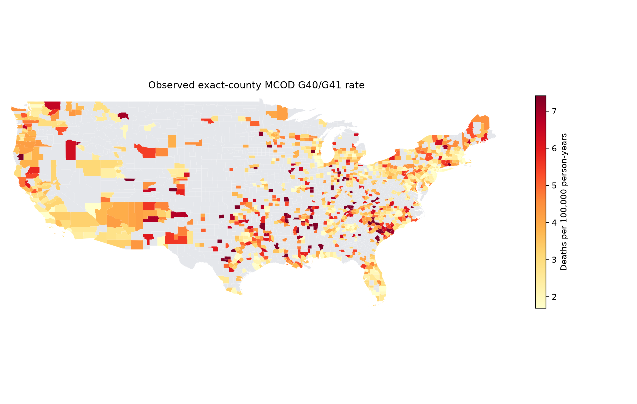
Figure S2. Rural/high-SVI priority map under residual allocation.
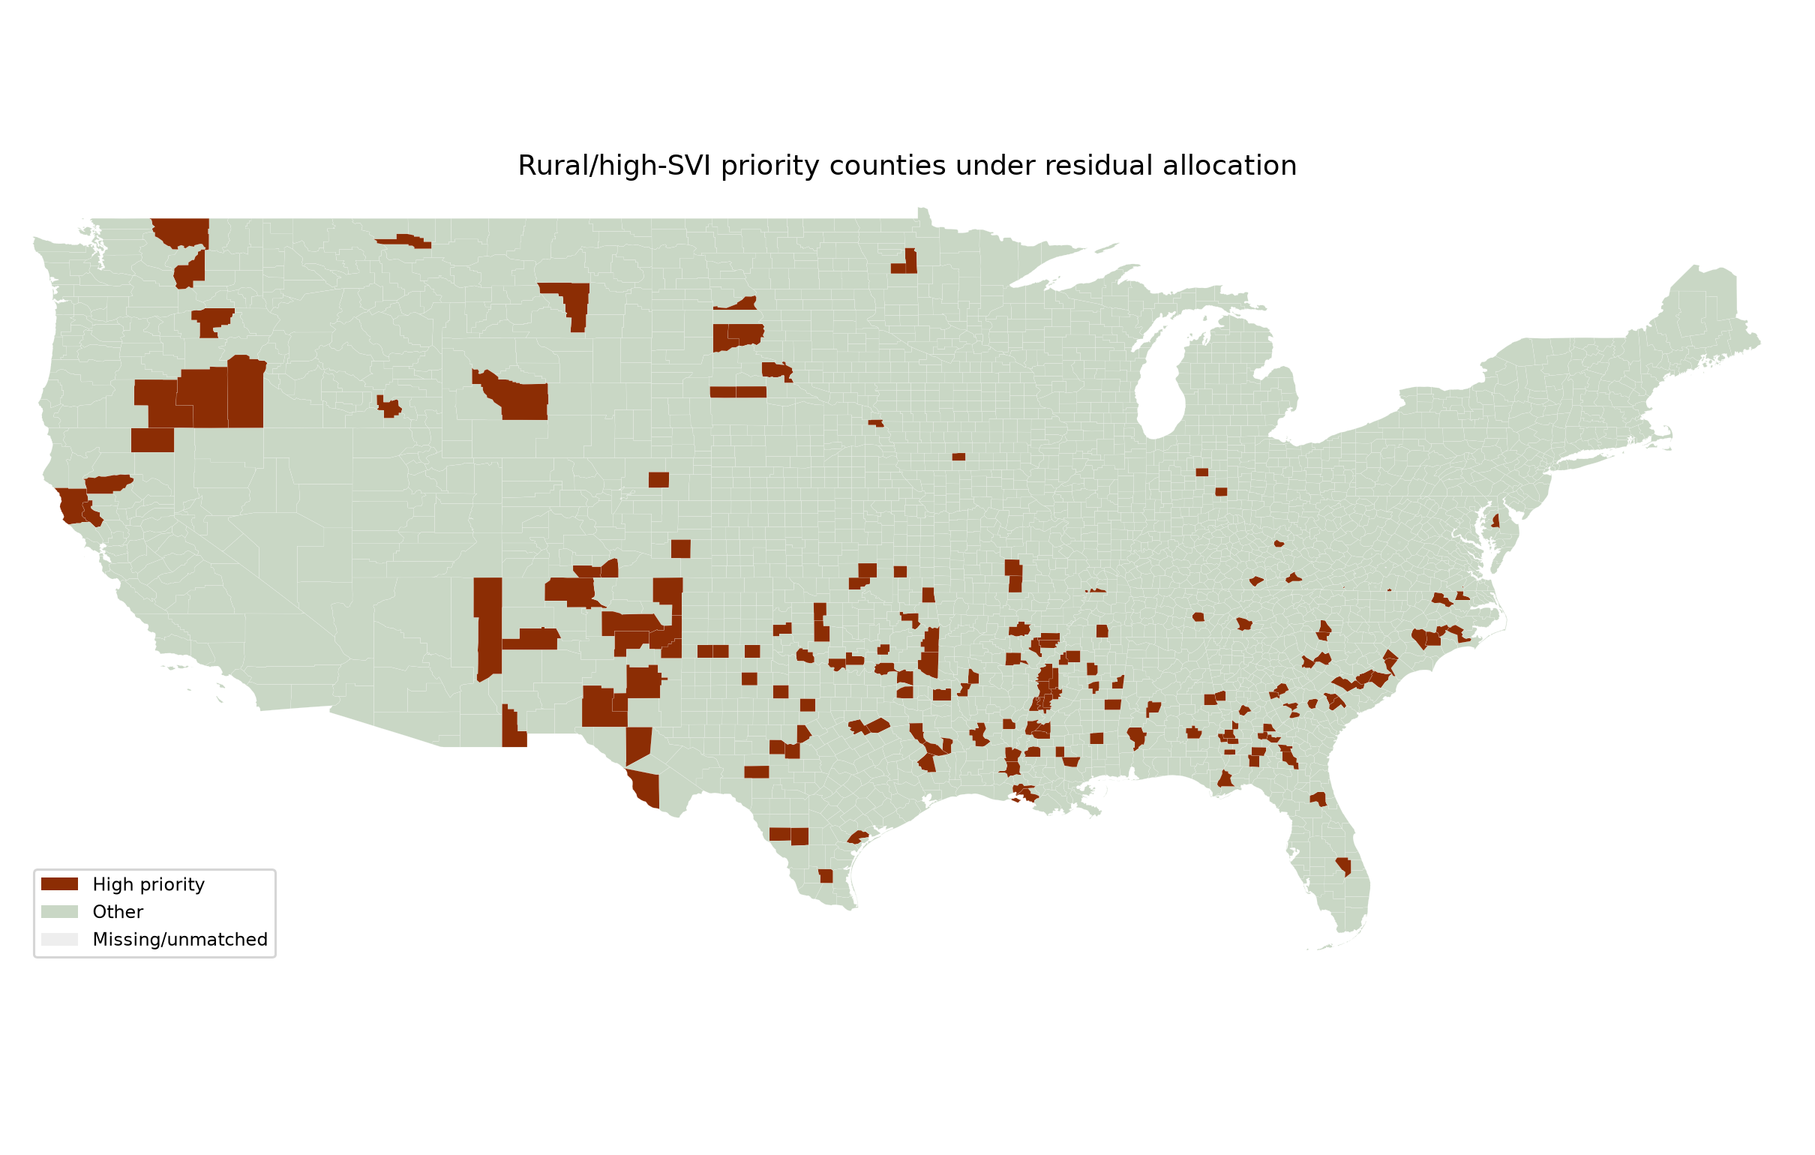
Figure S3. State-period multiple-cause G40/G41 mortality rate map.
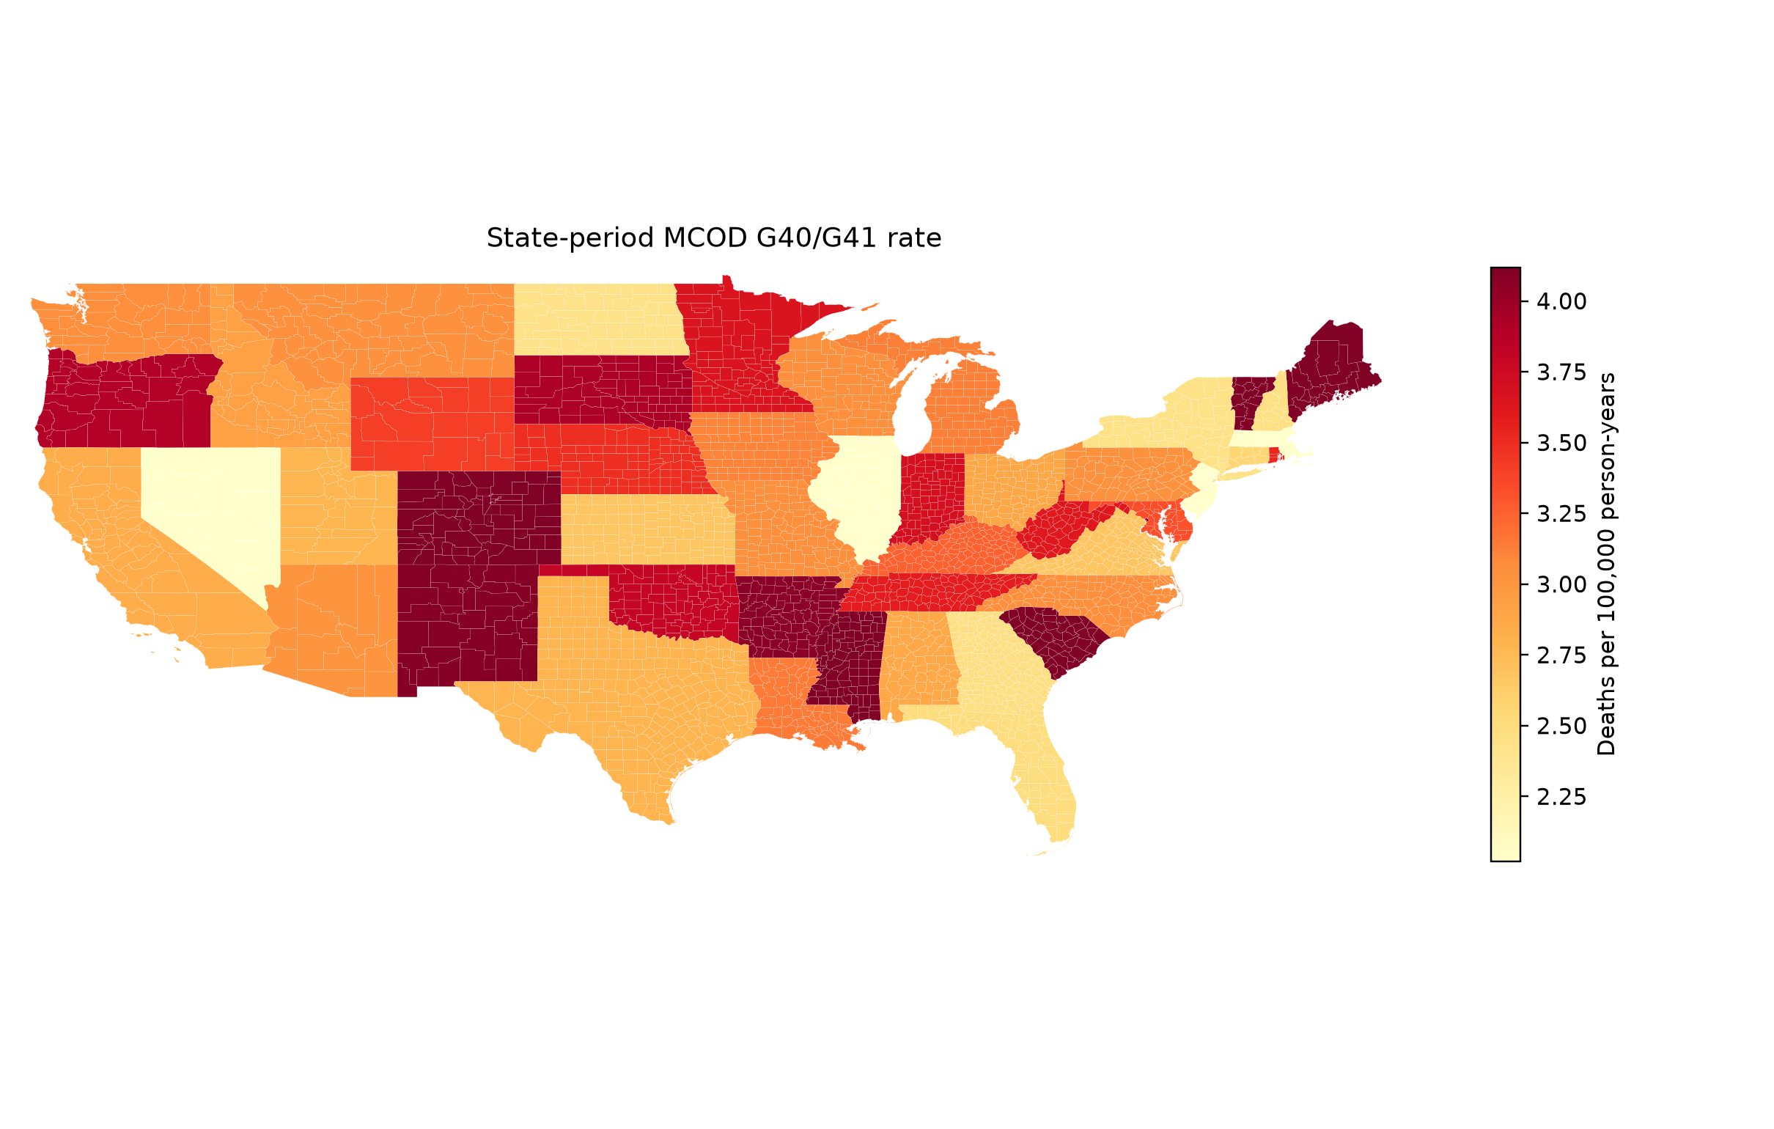
Figure S4. County underlying-cause G40/G41 suppression-status map.
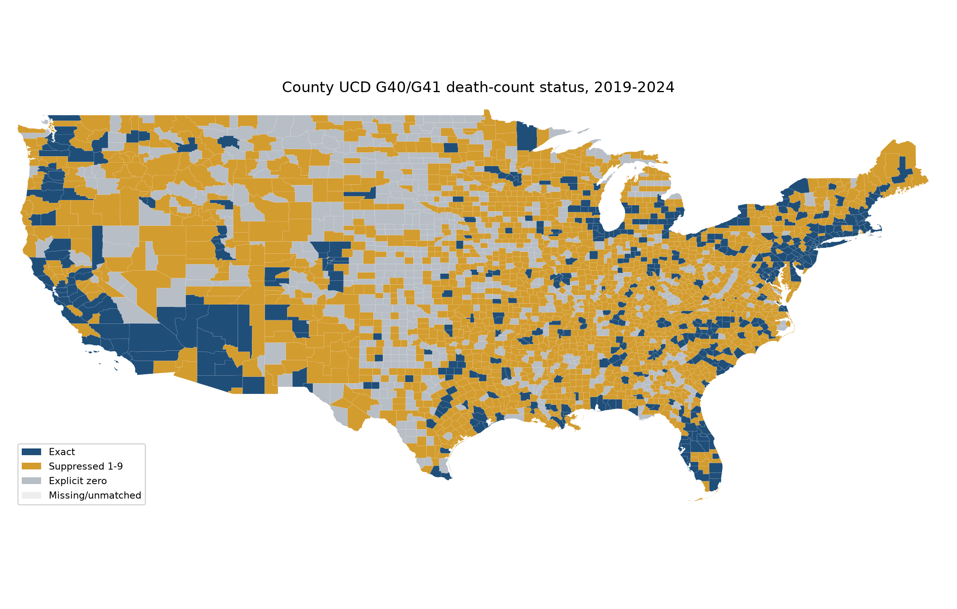
Figure S5. National-year mortality trend.
